- Create a concept map linking the following: Security Attacks, Threats, Risks and
Security Goals (Confidentiality, Integrity, Availability. Perform the following tasks:
  - Show how each attack leads to specific threats and risks
  - Map how security goals help mitigate them Provide one real-world

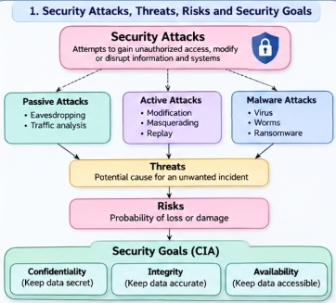

- Develop a concept map comparing substitution techniques: Caesar Cipher,
Monoalphabetic Cipher, Vigenère Cipher and Hill Cipher. Perform the following tasks
To connect based on: Key usage, Complexity and Security strength. Analyze which
Technique is most secure and why.

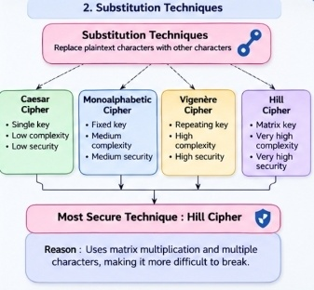

3.Construct a concept map for Classical Encryption Schemes: Substitution
Techniques and Transposition Techniques. Perform the following tasks:
- Show differences and similarities
i.Map how each affects the Data structure and Security level
ii.Analyze which is more vulnerable to attacks and why

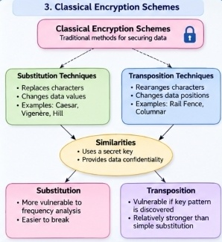

4.create a concept map connecting Steganography concepts: Data Hiding,
Watermarking and Survivability. Perform the following tasks:
- Show relationships between these concepts
- Analyze how each contributes to secure communication
- Include one real-world application for each
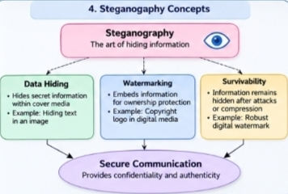

5. Draw a concept map linking number theory concepts used in cryptography:
Modular Inverse, Extended Euclid Algorithm, Fermat’s Little Theorem, Euler’s Phi
Function and Euler’s Theorem. Perform the following tasks:
- Show how each concept is mathematically connected
- Map their role in encryption/decryption
- Analyze which concept is most critical for public key cryptography

